**Task Description #2  
•** A function in Python that returns the maximum of three numbers using GitHub Copilot. Use an appropriate comment as a prompt.

Prompt: generate a code that allows three numbers and returns a largest value

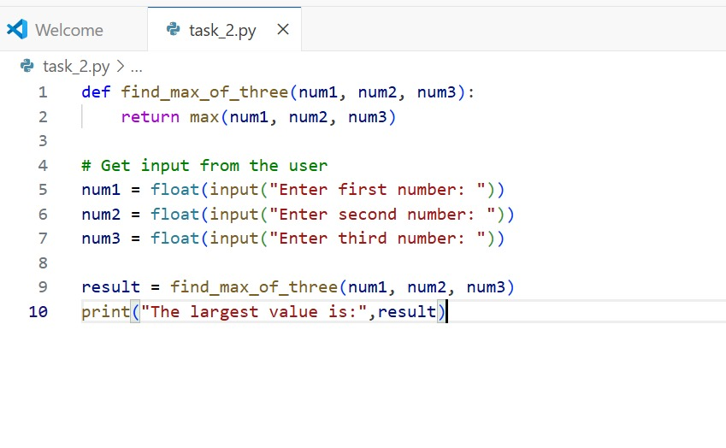

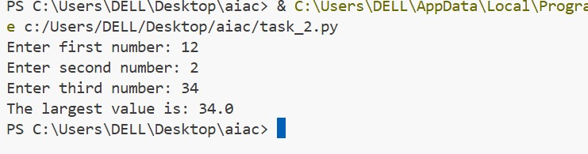

**Task Description #3  
•** Use GitHub Copilot to create a recursive Python function that calculates the factorial of a number.

Prompt: generate a code to create a recursive python function that calculates the factorial of a number and prints the value.

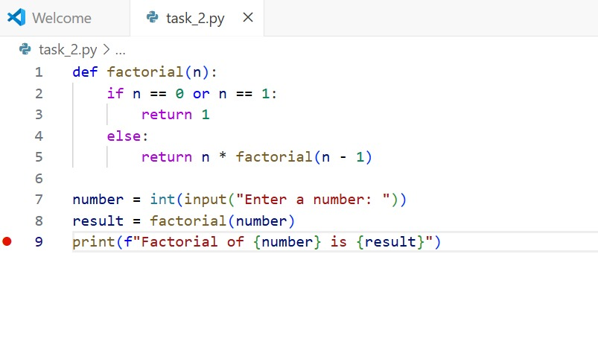

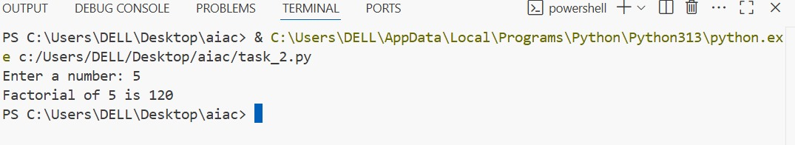

**Task Description #4  
•** Prompt GitHub Copilot to create a class named Student with attributes name, roll_no, and marks. Add a method to display student details.

Prompt: **create a python code to create a class named Student with attributes name, roll_no, and marks. Add a method to display student details . And allow the user to enter the number of students details and their details.**

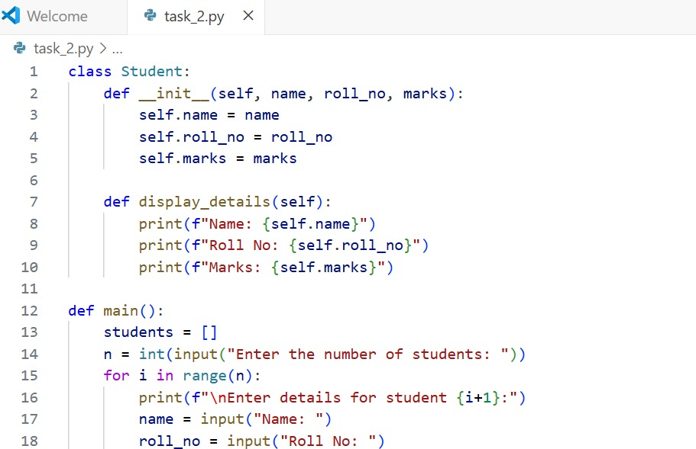

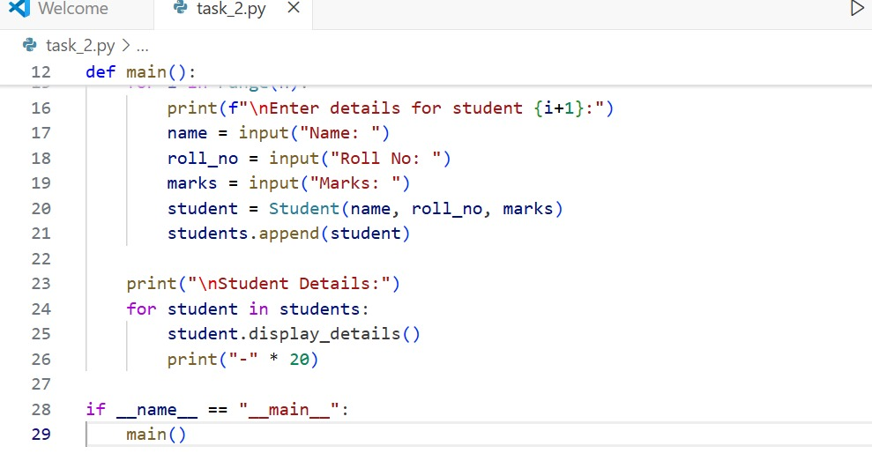

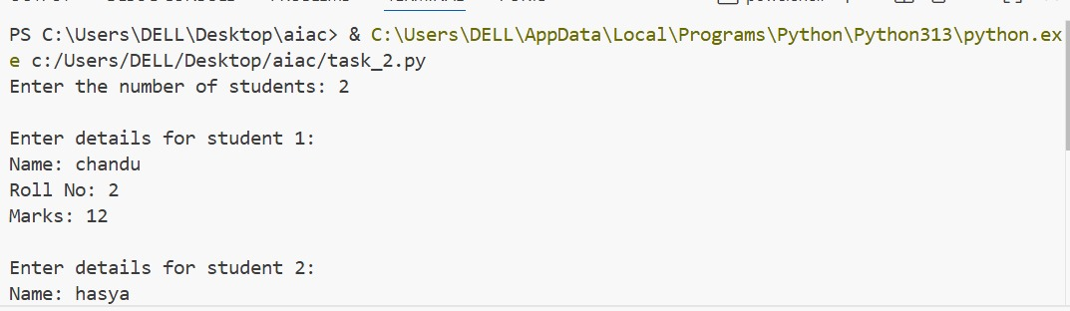

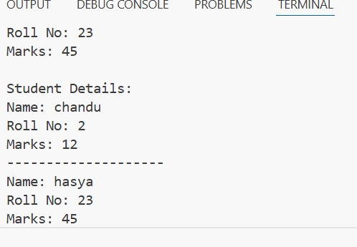

**Task Description #5  
•** Ask GitHub Copilot to generate a Python function that takes a string as input and returns the frequency of each word.

Prompt: Generate a Python function that takes a string as input and returns the frequency of each word.And alsothe input should be dynamic and display the frequency of each word.

